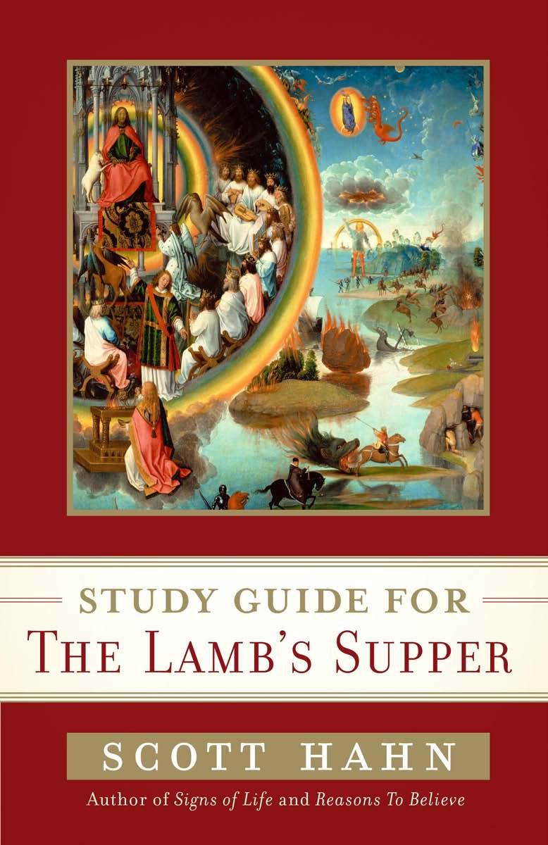
STUDY GUIDE FOR
Author of Signs of Life and Reasons Ta Relieve
THE LAMB'S SUPPER

Excerpted from:
The Lamb's Supper: Experiencing the Mass
Written by Scott Hahn
Copyright © 1999 by Scott Hahn.
Excerpted by permission of Image Books, a division of Random House, Inc. All rights reserved. No part of this excerpt may be reproduced or reprinted without permission in writing from the publisher.

How to Use This Book
You may use the book in any way you wish. For each session I have indicated a chapter of the book for advance reading. I have supplemented this “assignment” with pointers to other supplementary material—from the Bible, from the Catechism of the Catholic Church, and from other Church documents. I have also chosen, for each session, a hymn whose text is related to the discussion at hand. Singing sometimes loosens up the voices of discussion group members. And these traditional hymns will certainly give you something to talk about.
But my outline here is not intended to be a ritual. You’re free to use the elements that appeal to you and your group, in whatever order you please. You may skip whatever doesn’t work for you.
Sessiion 1
Foreword by Father Benedict Groeschel, C.F.R.
SUMMARY AND KEY POIINTS
- This book brings together several powerful spiritual realities.
- Eschatology is the study of “last things.”
- It is important that we conduct our study with a proper sense of the sacraments.
At my invitation, Father Benedict Groeschel wrote a foreword to The Lamb’s Supper. Father Benedict approaches the subject of the book from a very different perspective. He is a priest and I’m a layman. Father Benedict is a “cradle Catholic” and I’m a convert. Yet we converge upon a common faith; and, for very different reasons, we see a clear relationship between three realities that many people see as distinct or even unrelated: the Mass, the end times, and the Book of Revelation.
Father Benedict emphasizes the contrast between his own experience and mine. For me, the book is all about exciting “discoveries” I made in my studies. For him, the book is about an everyday reality he has known since he was an altar boy. These elucidations are not a novelty to him, but rather what he has “thought about the Eucharist for decades.”

Father Benedict also emphasizes certain things that are distinctive about Catholic doctrine and practice. He refuses, for example, to classify the Mass as a religious “service,” preferring terms such as “Divine Liturgy” instead. Similarly, he speaks of his own priesthood as a share in the priesthood of Christ, who is our only true priest.
He is especially concerned with the “sacramental” quality of the Church’s worship. According to tradition, a sacrament is an outward sign, instituted by Christ and entrusted to the Church. Through signs that can be perceived by the senses, the sacraments bestow divine grace.
Father Benedict notes that many people are disturbed by the prospect of the end of time, but he is himself at ease with the possibility of its fulfillment in his lifetime or its indefinite delay.
Along the way, he introduces us to certain key terms, such as eschatology, a theological term that refers to the study of last things. He encourages us to study “carefully” and “learn.”
Scripture
Revelation 4:8–11; 5:9–14; 7:10–12; 19:1–8
Doctrine
Catechism of the Catholic Church, n. 2642: The Revelation of “what must soon take place,” the Apocalypse, is borne along by the songs of the heavenly liturgy but also by the intercession of the “witnesses” (martyrs). The prophets and the saints, all those who were slain on earth for their witness to Jesus, the vast throng of those who, having come through the great tribulation, have gone before us into the Kingdom, all sing the praise and glory of him who sits on the throne, and of the Lamb. In communion with them, the Church on earth also sings these songs with faith in the midst of trial. By means of petition and intercession, faith hopes against all hope and gives thanks to the “Father of lights,” from whom “every perfect gift” comes down. Thus faith is pure praise.
Song
Come, Divine Interpreter
By Charles Wesley
(To the tune of “For the Beauty of the Earth”)
Come, divine Interpreter,
Bring me eyes your book to read,
Ears the mystic words to hear,

Words which did from you proceed,
Words that endless bliss impart,
Kept in an obedient heart.
All who read, or hear, are blessed,
If your plain commands we do;
Of your kingdom here possessed,
You we shall in glory view
When you come on earth to abide,
Reign triumphant at your side.
Questions for Reflection and Discussion
- Before reading this book, had you ever connected the Mass with the end times and the Book of Revelation? Had anyone ever made the connection for you?
- How, do you think (or would you guess), are these three things related?
- Is your own experience of the Mass closer to that of Father Benedict Groeschel or that of the author of this book? Or does your experience share elements of both? Explain your answer.
- How do you feel about the possibility of the world ending? What hopes or fears does it arouse in you?
- What, do you think, separates a sacrament from a mere “service” of the sort Father Benedict mentions?
- What will you look for in your study of “the end times”—your study of eschatology? What are your interests, concerns, expectations, or worries about the climax of history?
- Have you ever had an experience at Mass that you considered a glimpse or foretaste of heaven? Has anyone you know had such an experience?

